**Ideation Phase**

**Empathize & Discover**

|  |  |
| --- | --- |
| Team ID | PNT2022TMID17483 |
| Project Name | Gas Leakage monitoring & Alerting system for Industries |

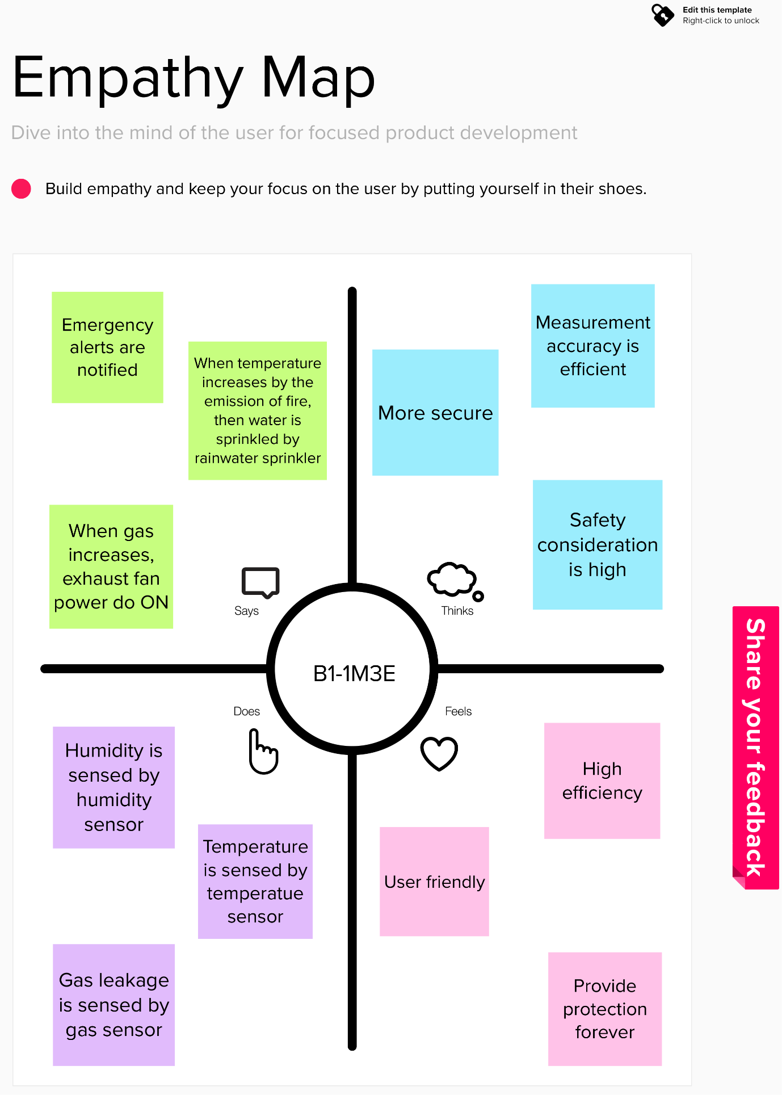

**EMPATHY MAP**